Geometry Unit
Grades 9 -12

Robert Berg, Saint Paul Public Schools; robert.berg@spps.org
Kevin Brenner, Cloquet Senior High School; kbrenner@isd94.org
Bill Garnett, Duluth East Senior High School; william.garnett@isd709.org

Executive Summary

The Minnesota State Math Standards that are addressed in this unit are as follows:

Standards:

NCTM standard G1: Analyze characteristics and properties of 2- and 3-dimensional geometric shapes and develop mathematical arguments about geometric relationships.
- Analyze properties and determine attributes of two- and three-dimensional objects.
- Explore relationships (including congruence and similarity) among classes of two- and three-dimensional geometric objects, make and test conjectures about them, and solve problems involving them.
- Use trigonometric relationships to determine lengths and angle measures.
NCTM standard G4: Use visualization, spatial reasoning, and geometric modeling to solve problems.
- Use geometric models to gain insights into, and answer questions in, other areas of mathematics.
- Use geometric ideas to solve problems in, and gain insights into, other disciplines and other areas of interest such as art and architecture.
MN Math Standard 9.3.4.2: Apply the trigonometric ratios sine, cosine and tangent to solve problems, such as determining lengths and areas in right triangles and in figures that can be decomposed into right triangles. Know how to use calculators, tables or other technology to evaluate trigonometric ratios.

MN Math Standard 9.3.4.3: Use calculators, tables or other technologies in connection with the trigonometric ratios to find angle measures in right triangles in various contexts.

MN Math Standard 9.3.3.6: Know and apply properties of congruent and similar figures to solve problems and logically justify results. For example: Analyze lengths and areas in a figure formed by drawing a line segment from one side of a triangle to a second side, parallel to the third side. Another example: Determine the height of a pine tree by comparing the length of its shadow to the length of the shadow of a person of known height. Another example: When attempting to build two identical 4-sided frames, a person measured the lengths of corresponding sides and found that they matched. Can the person conclude that the shapes of the frames are congruent?

MN Math Standard 9.3.4.6: Use numeric, graphic and symbolic representations of transformations in two dimensions, such as reflections, translations, scale changes and rotations about the origin by multiples of 90˚, to solve problems involving figures on a coordinate grid. For example: If the point (3,-2) is rotated 90˚ counterclockwise about the origin, it becomes the point (2, 3).

Learning Opportunities:

Students will be asked to investigate and explore activities that will introduce them to fractals, review area, and apply laws of triangles. Students will also be exposed to transformations and dilations of figures within a coordinate plane. The navigation lessons will give students a chance to review their understanding of formulas and rules that apply to triangles, parallel lines, and angles.

Sample MCA Questions:

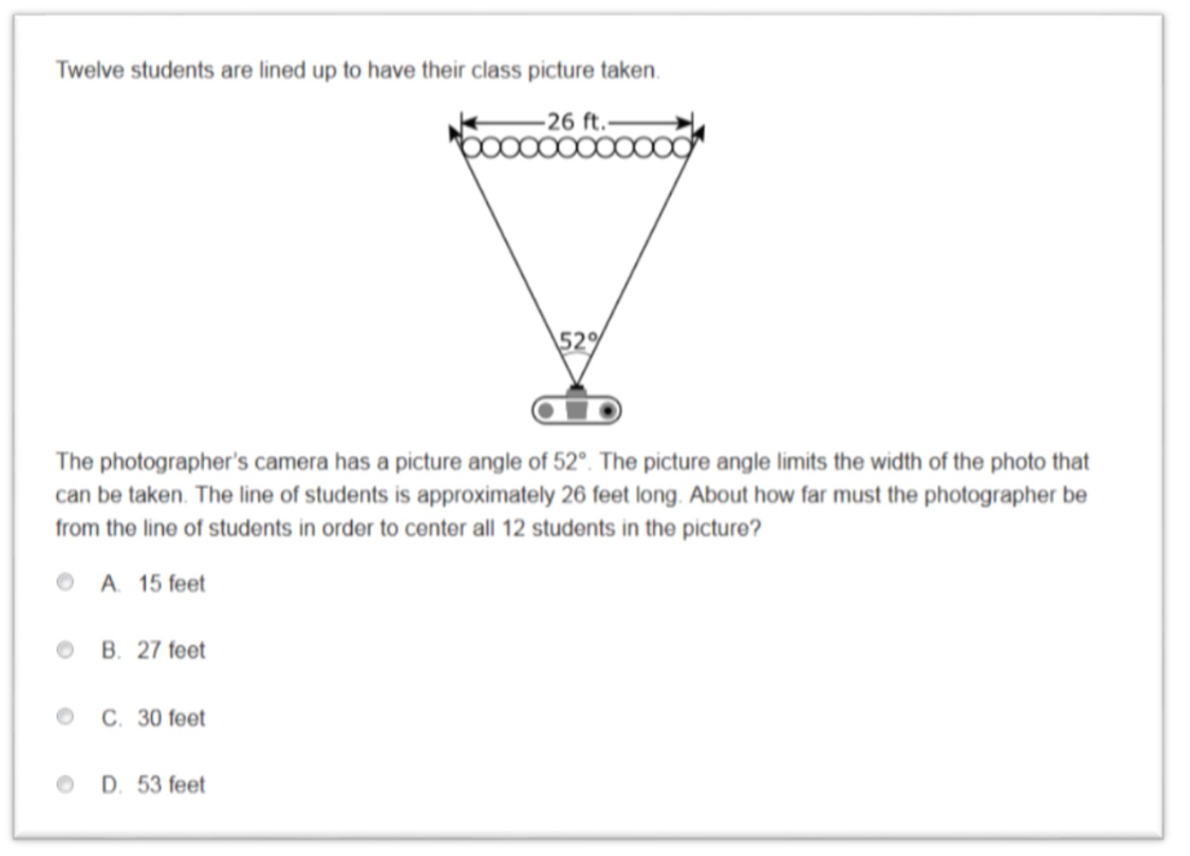

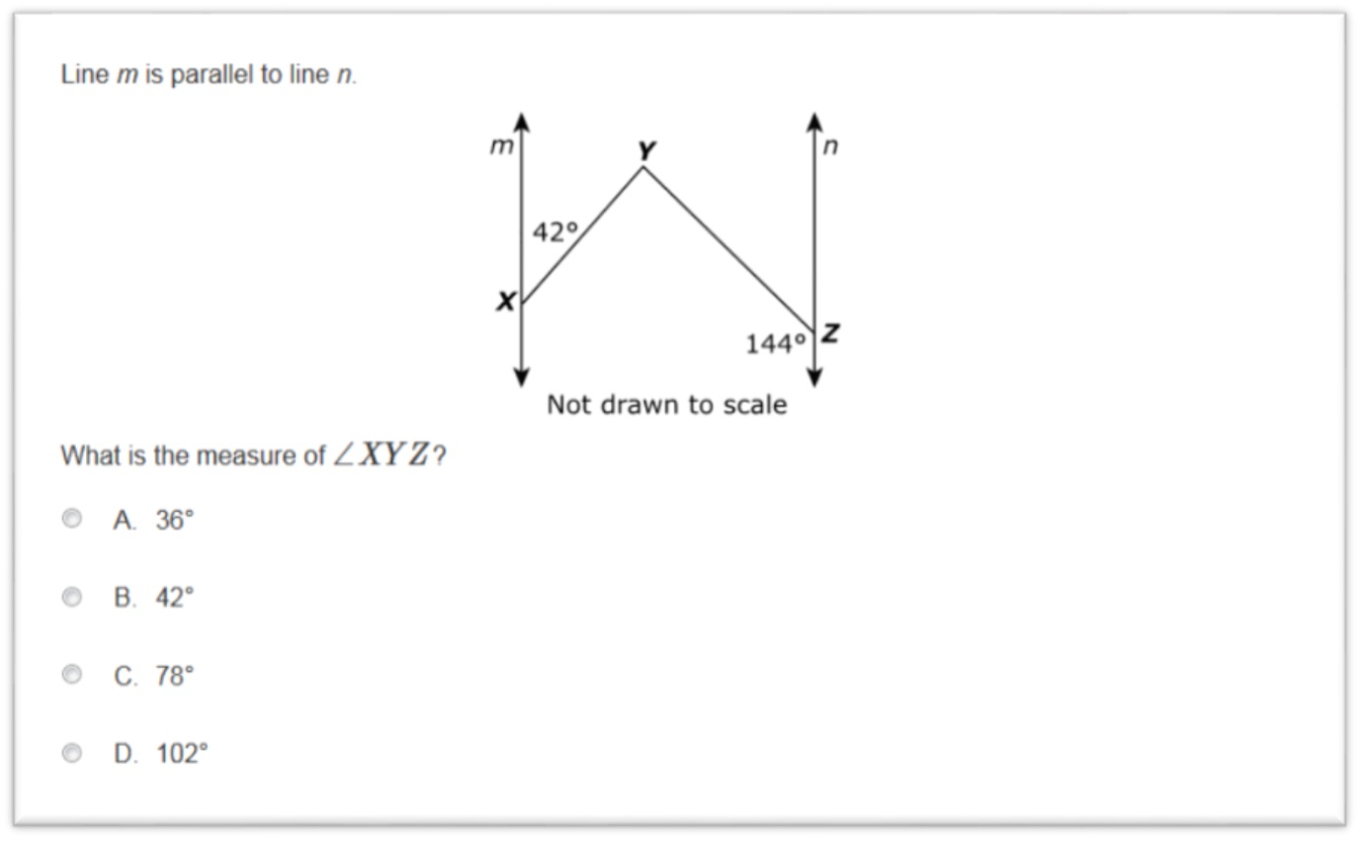

Table of Contents

Day 1: Transformations………………………………………........... Page 6
Day 2: Jewel Heist Problem………………………………………… Page 8
Day 3: Navigation Using Parallel Lines…………..……….…… Page 11
Day 4: Dilations…………………….…………………………………… Page 13
Day 5: Dissections…………………...…………………………………. Page 15
Day 6: Fractal Introduction……………………………….……….. Page 17
Day 7: Sierpinski Triangle and Geometric Series…..…….. Page 18
Day 8: Sierpinski Triangle……………………………………….….. Page 20
Day 9: Koch Curve…………..………………………………………….. Page 21
Day 10: Fractal Tree…………………………..……………………..... Page 22
Day 11: Triangle Properties and the Law of Sines….…..… Page 24
Day 12: Using the Law of Sines………………………………….... Page 25
Day 13: Jack’s Shack Sandwich Shop……………..……..……... Page 26
Day 14: Bearings and Treasure…………………………..………. Page 27
Day 15: Trig Treasure Hunt…………………………………..……. Page 32
Pre Test……………………………………………………………………… Page 35
Post Test.……………………………………………………………………. Page 36

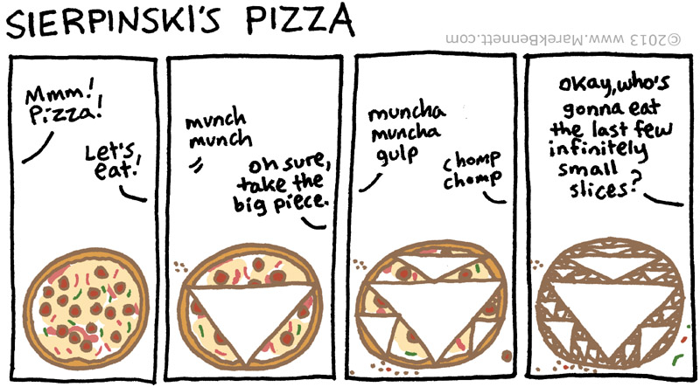

Day 1
Transformations

Objective: Students will be able to map a pre-image onto an image using more than one step of transformations.

Launch: The introduction to this lesson should include some instruction and examples on transformations that include just one step. Vocabulary terms such as ‘slide’ and ‘reflect’ could be used to describe these transformations. This is also a good opportunity to review plotting points on the coordinate plane.

Explore: Students should be given the handout on the following page and begin exploring transformations that require two steps.

Share: After giving students enough time to complete these transformations they could be asked to show their work at the board. It should be noted that there is often more than one solution process for these type of transformations. So, students should be able to demonstrate the transformations with at least two different processes. This is will make an excellent topic for discussion.

Summarize: Draw a pre-image and image on the board at ask students to describe how to make the transformation work. Ask students to give specific points for each step and explain the transformation process using the proper vocabulary that was emphasized at the beginning of class.

In Exercises 1 and 2, each image was the result of more than one transformation of the preimage. Show the steps that you can use to get from the preimage to the image. Graph the intermediate image and describe each step.
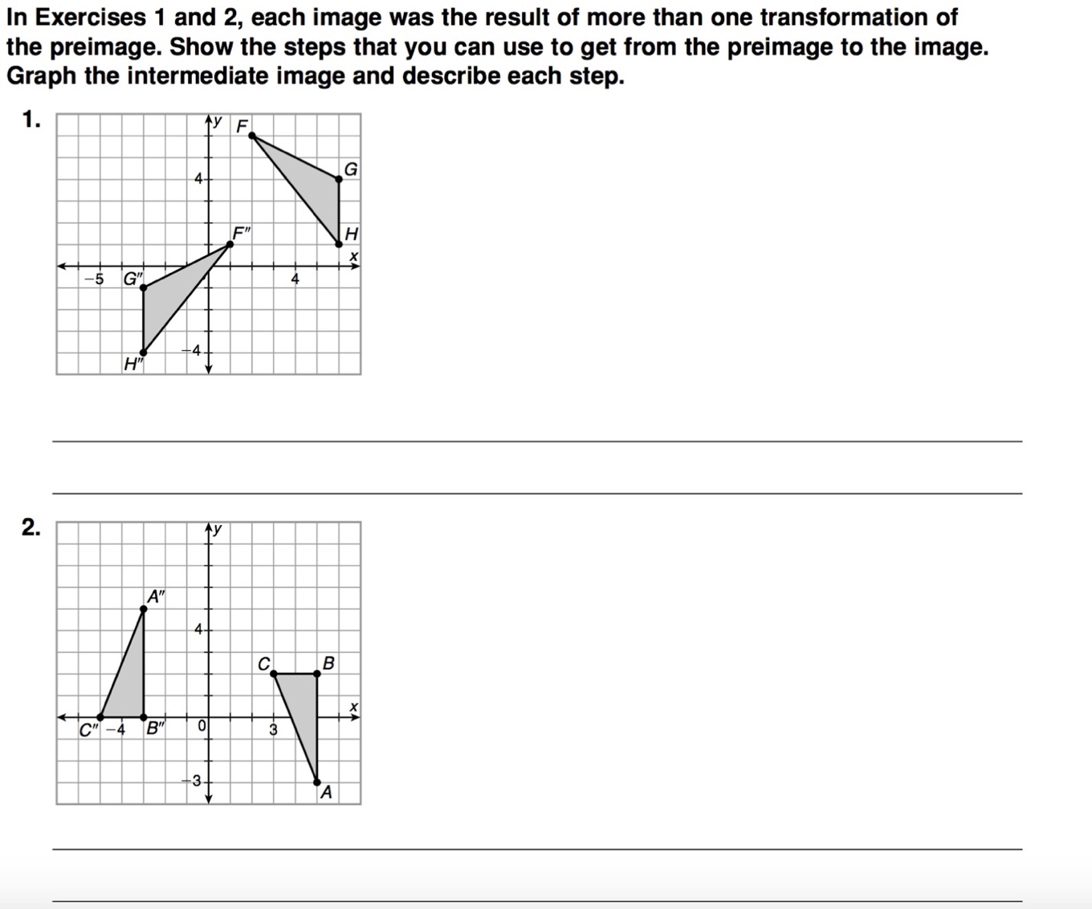
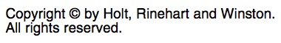
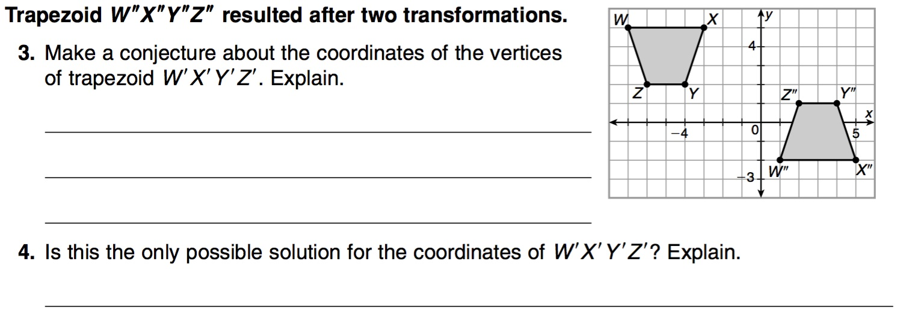

Day 2

How to Plan a Jewel Heist

Objective: Students will be able to calculate the area of a composite figure. They will also be using their area calculations in order to calculate the probability of an event happening (geometric probability).

Launch: Review how to find the area of rectangles, squares, and triangles. Then, give some examples of how to find the area of figures that involve more than one of the shapes that were reviewed (composite figure). Depending on the student’s ability level the teacher may want to review how to calculate the probability of an event occurring.

Explore: Students should be given the handout on the following page. This should be completed in groups.

Share: Students should be asked to share their results to each question. Students could do this with poster paper – groups could be asked to walk around and discuss the problem with other groups. Alternatively, each group could present their results and this could lead to a whole class discussion about the problems that were investigated.

Summarize: Students should be asked to create their own problem that involves a composite figure. This problem could be used on the unit test or quiz.

How to Plan a Jewel Heist

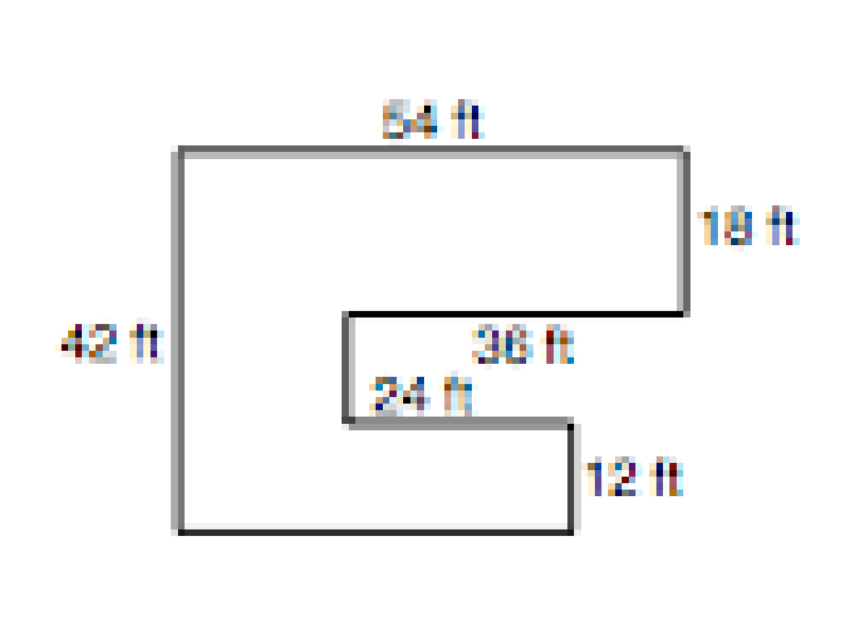
1. A burglar plans to steal a precious jewel from the building shown in the figure.
The burglar has not been able to find out where the jewel is in the building. The building has two floors. He can search 50 square feet every minute, but an alarm will sound after 10 minutes. Find the probability the cat burglar will find the jewel before the alarm sounds.

Extension
On average, how many square feet per minute would the burglar need to search in order for him/her to have a 75% chance of finding the jewel before the alarm sounds after 10 minutes?

Bonus
Find the number of minutes and seconds the burglar would have to search to have a 50% chance of finding the jewel.

If Time Permits-
If you were to advise someone considering a career as a burglar, based upon the information you discovered in this problem, what would you advise?

2. Painting a Wall
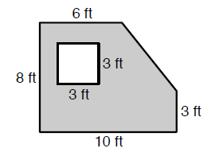
Jessica wants to paint one wall in her bedroom as shown in the picture. The cost of paint is $7 per quart and each quart covers 60 square feet. If Jessica has a budget of $14, will she be able to apply two coats of paint on her wall? Justify your answer.

Day 3

Navigation Using Parallel Lines

Objective: Students will be able to ‘heading’ or ‘compass bearing’ required to navigate between two points in a plane.

Launch: Review the vocabulary, concepts, and properties of angles associated with two parallel lines cut by a transversal. Then, discuss the concepts and vocabulary used when people talk about compass headings (north, south, southeast, etc.). Remind students that compass headings are always in calculated from ‘due north’ from the point of the ship to its destination (clockwise). The teacher could show a video or animation to help students understand a compass. (ex. http://geographyfieldwork.com/UsingCompassDemo.htm or https://www.youtube.com/watch?v=xKSBYfscA80)

Explore: Students should be given the handout on the following page. They will need rulers, scissors, paper clips, etc. to complete this task)

Share: Students should be asked to come to the board and explain how to calculate the compass heading for different situations. The teacher can lead the discussion back to the use of parallel lines and could also expend this discussion to include more technology that is available and what type of careers may need to know this information (ex. Surveyors, fishermen, etc.)

Summarize: Students should be asked to summarize their learning by writing a description (or steps) of how to calculate compass heading – their description should be detailed enough for someone else to follow. For homework (or if time allows in class) students could pair up to take someone else through their steps to see if it works.

Navigation Using Parallel Lines
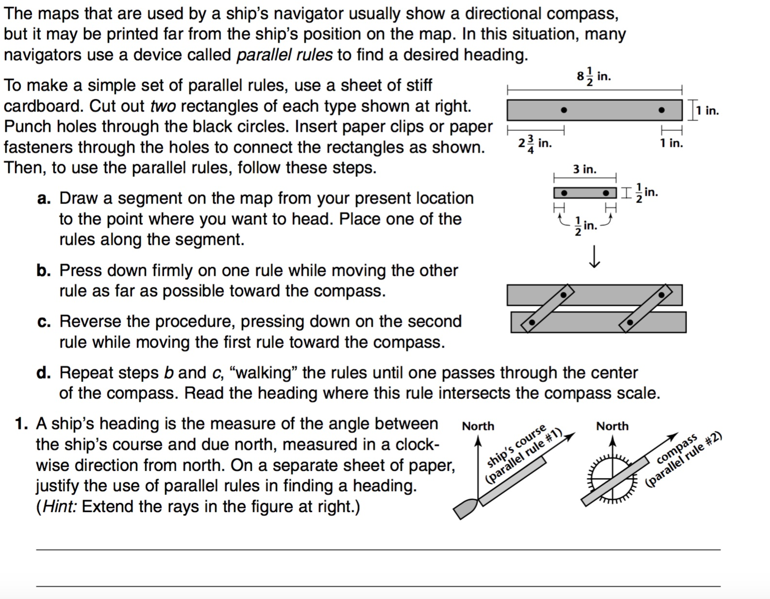
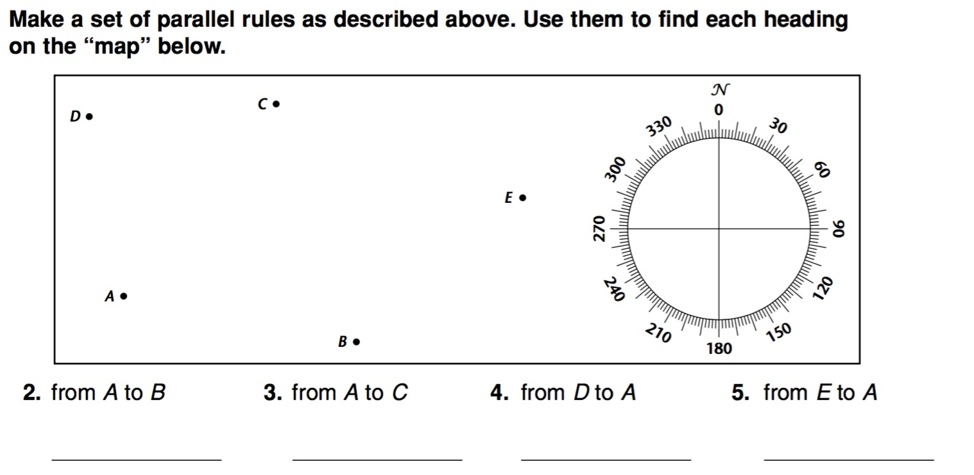

Day 4

Dilations

Objective: Students will be able to write rules for dilations that transform different polygons in a plane.

Launch: The introduction to this lesson should include some discussion and examples of dilations of lines and polygons that are centered at the origin. The concept of scale factor should be introduced and discussed in depth before moving into the student activity. Translations may also need to be reviewed – depending on how much students remember about them.

Explore: Students should be given the handout on the following page. Students may need to work in groups to successfully complete this activity.

Share: Students should be asked to share their responses to questions 2, 3, 4, and 5. Students could do this with poster board, or by coming to the board to share their sketches and explain the process they took to get their dilations to work out.

Summarize: Students could be given an exit ticket at the end of class – give the students several ordered pairs of numbers to represent a pre-image and an image and ask them to come up with the rule for the dilation.

Dilations

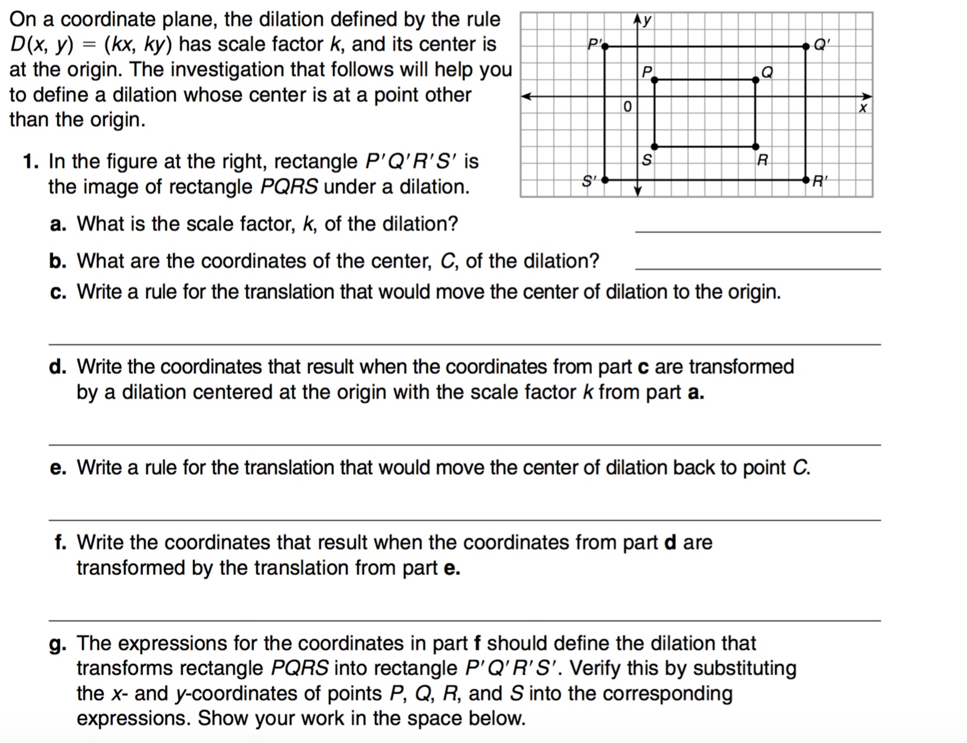
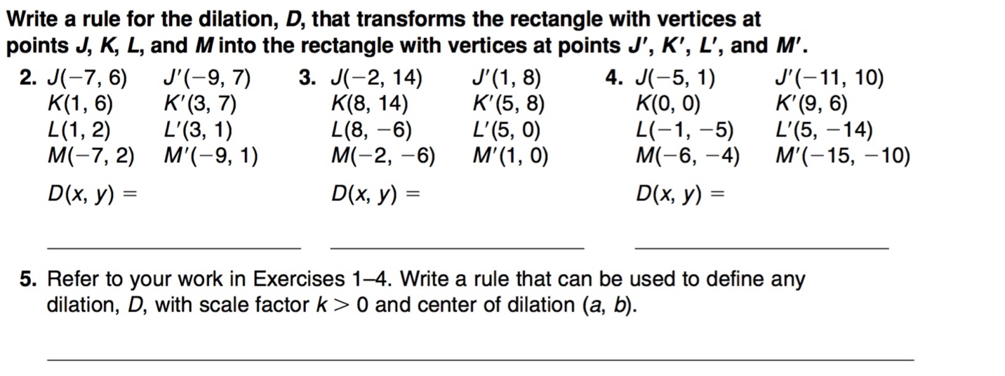

Day 5

Dissecting Polygons

Objective: Students will be able to dissect any regular n - gon into n congruent polygons.

Launch: The introduction to this lesson may need to include the characteristics of regular polygons and congruent polygons. Discuss the differences and similarities of what it means for a polygon to ‘regular’ and what it means for a polygon to be ‘congruent.’ Draw sketches on the board and make lists of the different characteristics if each type.

Explore: Students should be given the handout on the following page. Students will also need scissors and blank paper for their polygons.

Share: Have students come up and show their different dissections. Discuss the different ways that a regular polygon can be dissected. Lead the discussion in an effort to get students to describe their process for dissecting polygons into congruent polygons. This discussion could be extended to include area, perimeter, and angles of polygons before and after they are dissected.

Summarize: Students 3 -5 sentences to summarize what techniques should be used when dissecting regular polygons. Ask students to also consider dissecting polygons that are not necessarily regular and if their techniques would still work for these shapes.

Dissecting Polygons

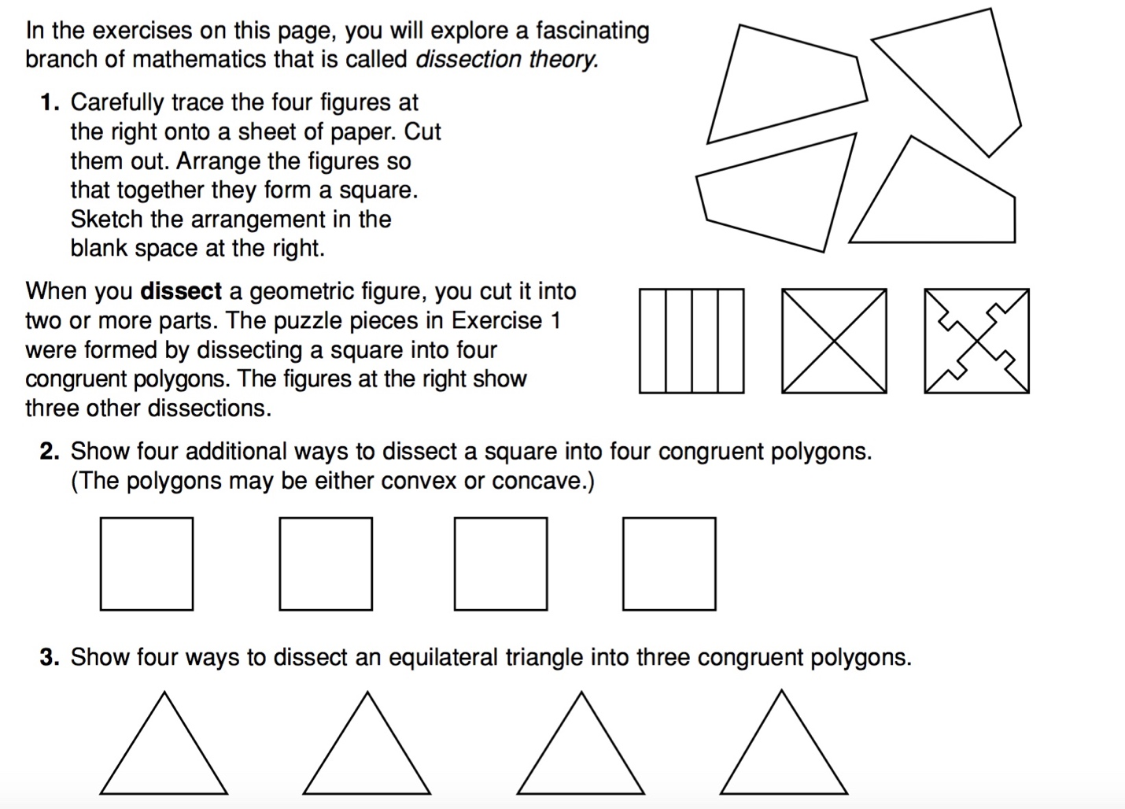
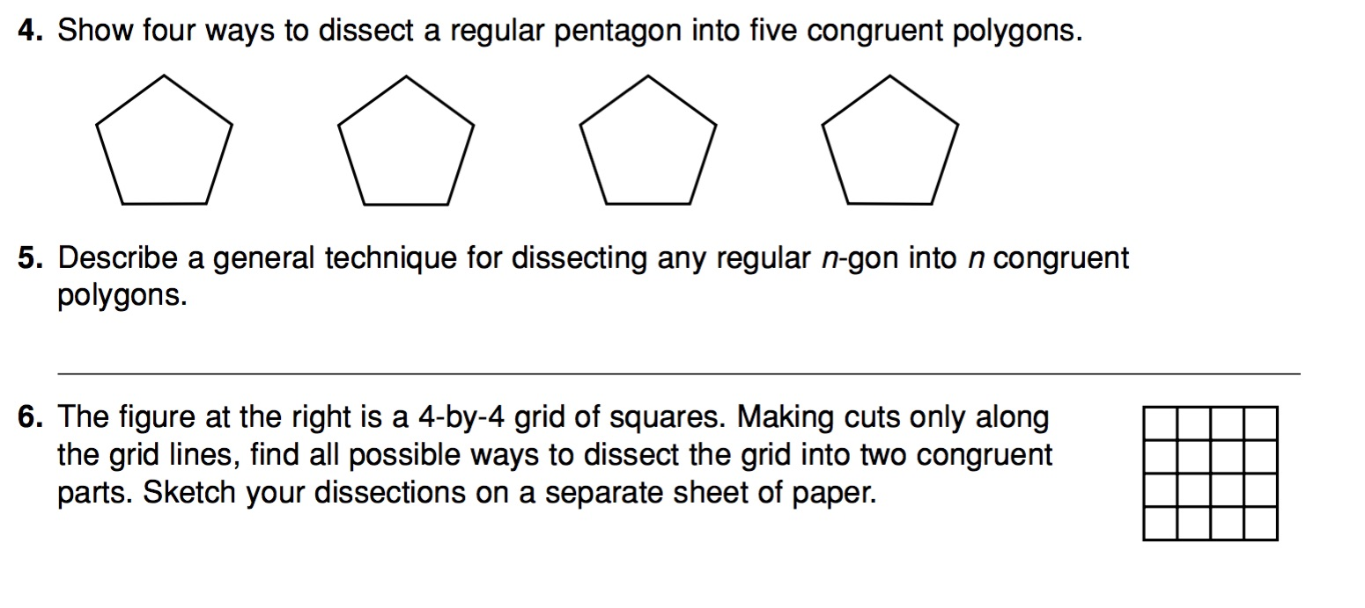

Day 6

Fractal Introduction

9.3.3.6 Know and apply properties of congruent and similar figures to solve problems and logically justify results.

9.3.4.7 Use algebra to solve geometric problems unrelated to coordinate geometry.

Launch
We are going to explore what kind of pictures your names create.

Explore
Each person gets a sheet of graph paper.
“At the top of the page, print your name, one letter per box. Now repeat leaving no spaces between your names and fill the top line”
“We are now going to add the magic word, LURD. Write this below your name and repeat as before”
Put this chart on the board:
A J S 1
B K T 2
C L U 3
D M V 4
E N W 5
F O X 6
G P Y 7
H Q Z 8
I R 9
“Now find the numbers that correspond to the letters in your name and add them on the third line”
“L is Left, U is Up, R is Right, D is Down. Start at a point in the middle of the paper and use these directions with the numbers as distance and draw the picture your name gives”

Share
“Compare your drawing with those around you and look for patterns. Where there any common patterns?” “What would happen if your name was “Adam?”

Summary
There are certain patterns that repeat. Boxes that close in and retrace, spirals that go off the page. This gives some of what the idea of a fractal is. Self-similarity and a pattern that repeats.

Day 7

Sierpinski Triangle and Geometric Series

9.3.3.6 Know and apply properties of congruent and similar figures to solve problems and logically justify results.

9.3.4.7 Use algebra to solve geometric problems unrelated to coordinate geometry.

Launch
We know what a geometric sequence is, so how would you add up a geometric series? Can we make a physical representation of a geometric series.

Explore
We are going to create a Sierpinski Triangle, but we will only be concerned with the triangles formed that face “DOWN” We need to start with a large equilateral triangle. Cut the triangle into four congruent equilateral triangles. Each triangle has an area of ¼ the original. Keep the top triangle and put the others in three different piles. Repeat the process as far as you can.
What fraction of the original triangle is in each pile?

Summary
The geometric series explored here has ¼ as its first term and ¼ as its common ratio.

$S_{n}= a_{1}\left(\frac{1}{1-r}\right)$ which gives us $\frac{1}{4}\left(\frac{1}{1-\frac{1}{4}}\right)=\frac{1}{3}$

Navigating Through Geometry in Grades 9-12 NCTM
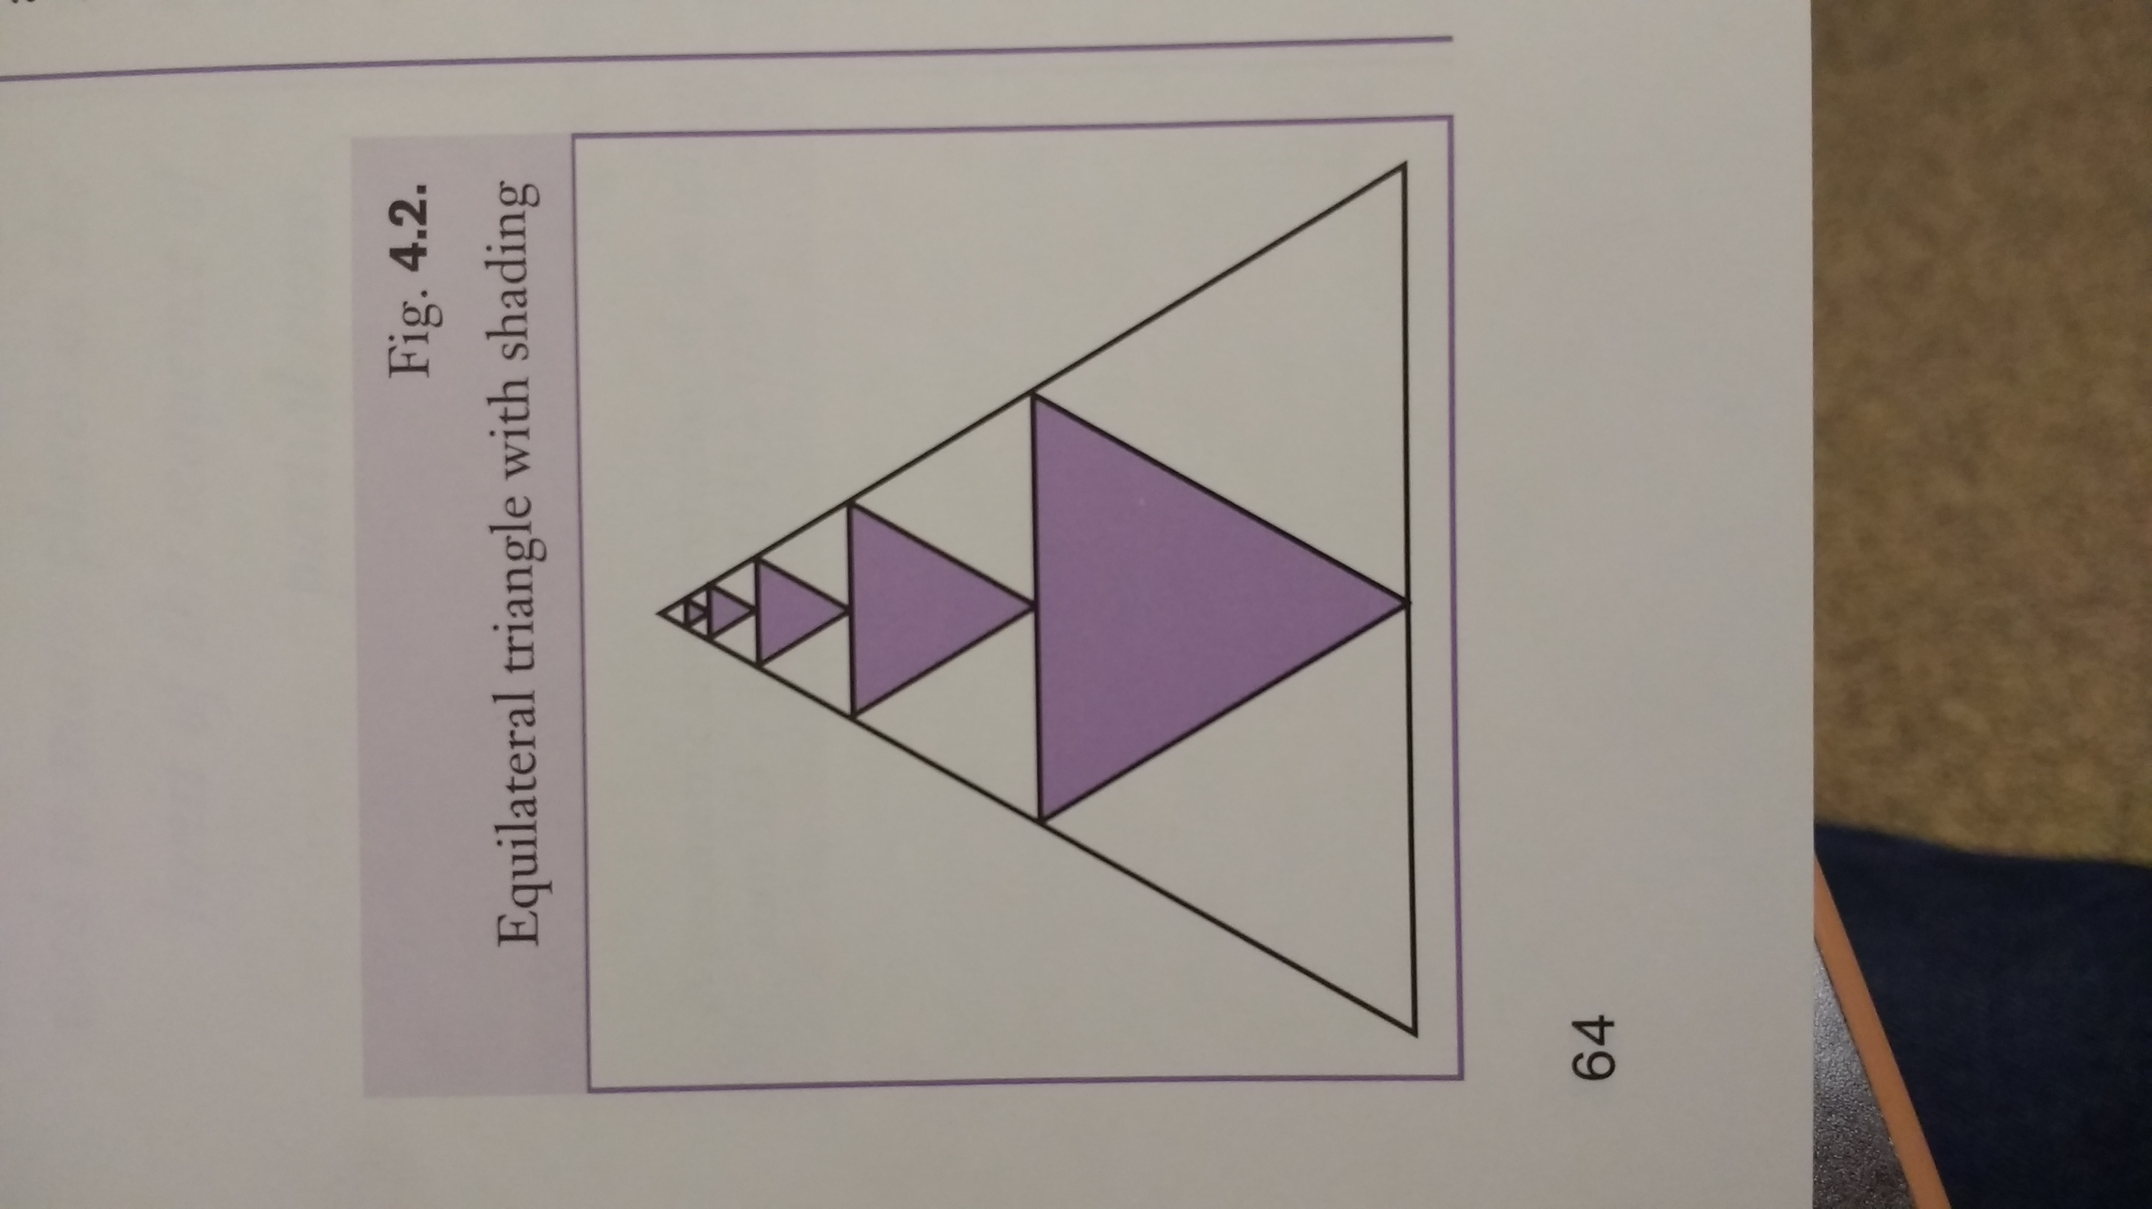

Day 8

Sierpinski Triangle

9.3.3.6 Know and apply properties of congruent and similar figures to solve problems and logically justify results.

9.3.4.7 Use algebra to solve geometric problems unrelated to coordinate geometry.

Launch
We are going to use recursive rules to construct a special triangle and explore that patterns that can be found in the triangle. We are going to create a “Sierpinski Triangle.”

Explore
Each person gets a sheet of blank paper. And a chart that looks like:
Stage Number 0 1 2 3 4 ----- n ------- 50
# of Triangles
Un-shaded Area
Perimeter
“Draw a large triangle on your paper. We will call this stage 0. Fill in the answers for stage 0 (1,1, 3)
For each of the next few stages we will repeat this process: connect the midpoints of the three sides of any triangle that is not shaded. Shade the middle triangle of the four created. Answer the questions for the next stage. Each time you repeat this is a new stage. Try to 3 or 4 stages. Once you have done this, look for patterns to do stage n and then find your answer for stage 50.”

Summary
Students will share their answers and talk about the pattern for stage n. Have them check their formulas for stage n with earlier stages and then look at their answers for stage 50.

Discovering Geometry an Investigative Approach
Day 9

Koch Curve

Launch
To really measure a coastline is very difficult. As you zoom in on a coastline, it displays a fractal like shape. We are going to create a fractal that will mimic a coastline and see why it is so difficult to get an exact answer for its length.

Explore
We are going to make a Koch Curve. Start by drawing a segment that is 12 centimeters long. This is stage o. Now erase the middle third of that segment and over the open segment, draw two sides of an equilateral triangle that has the length of the remaining sides. This creates stage 1.

Find the length of stage 1 and then repeat the process on the 4 segments in your drawing to make stage 2. Create a table to keep track of the number of segments and the total length at each stage.

Repeat this process 2 more times.

What is happening to the length as you add more stages to your drawing?
Can you predict what would happen at the next stage? At the nth stage?
What does this say about our ability to accurately measure coastlines?

Summary
At each stage there are 4 times as many segments as the previous on and the length of each segment is one-third the previous length. The total length is four-thirds as long at each step. As we move in close on a coastline, it will be measured more accurately then the step before and increase in length.

Fractal Foundation – www.FractalFoundation.org

Day 10

Fractal Tree

9.3.3.6 Know and apply properties of congruent and similar figures to solve problems and logically justify results.

9.3.4.7 Use algebra to solve geometric problems unrelated to coordinate geometry.

Launch
We have introduced the idea of fractals. Now, we will create a fractal tree and explore the patterns found as we move from stage to stage and see if we can generalize the nth stage.

Explore
You will get a worksheet that shows stage 1, 2 and 3 of a fractal tree. Put the data for each stage in the chart and start to look for patterns. Complete the next 4 stages and add that information to the chart. Can you generalize a formula for each of the answers in the nth step?

Share
When they find the formula, $3^{n-1}$, see if they can represent this expression in different ways. What kind of formulas are these? That last column will need a recursive formula.
The solutions are $3^{n-1}$, $\frac{1}{2^{n-2}}, \frac{2^{n}-1}{2^{n-2}}, \frac{3^{n-1}}{2^{n-2}}, \sum_{i=1}^{n}{(3^{i+1})(2^{2-i})}$

Summary
The fractal tree has formulas that are geometric series. The students might struggle trying to find a “nice” formula for the last column.

betterlesson.com/572914/the-fractal-tree

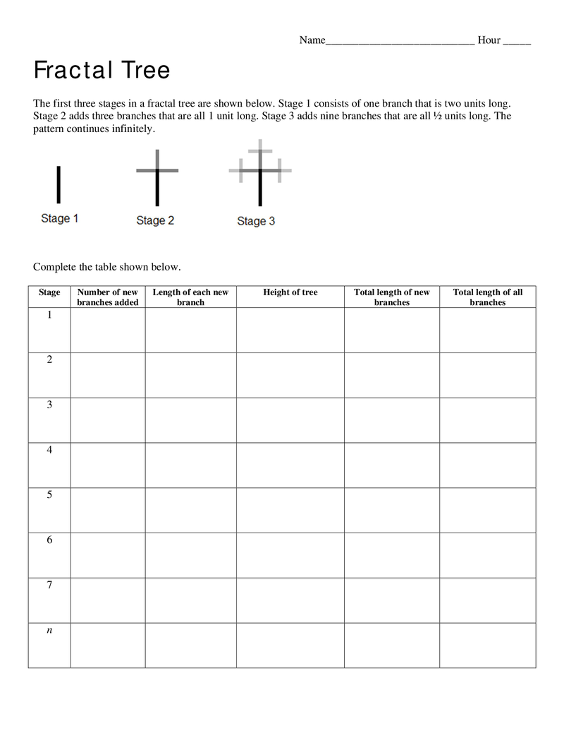

Day 11

Triangle Properties and the Law of Sines

Objectives: Students will review general triangle properties and develop the law of sines.

Pretest: Direct students to Quizizz.com to take the Ambiguous Triangle, Law of Sines, and Bearings Pretest.

Launch: Rumor has it there are tunnels underground between the Cloquet school buildings. Lunch may or may not be carried through these hypothetical tunnels. Imagine you and a friend found 3 such tunnels connecting Washington, CHS Auto shop, and the Middle School Pool. The tunnel from Washington to the Auto shop is 2900ft and lies at a bearing of 10 degrees. The tunnel from Washington to the Middle School Pool has a bearing of 15 degrees. The tunnel from the Auto shop to the Middle School Pool has a bearing of 85 degrees. If you and your friend walk a complete circuit through the tunnels, how far will you have walked?

Explore: Break students into groups of 3-4 students.
- They may solve the problem or determine what other things they need to know or learn to complete the problem. (5 min)
- Challenge groups to list as many properties as they can about triangles. (5-10min)
Share: Groups are to add their properties into the chart started by the teacher on the board. The chart will have two columns: Right Triangle Properties and Oblique Triangle Properties.

Summarize: The teacher concludes this part of the lesson my defining an oblique triangle, revising any notations about triangles, and making sure the following properties have been recalled: Angle sum = 180, Triangle inequality theorem (a+b>c) , Sides inequality theorem (if A>B, a>b), Pythagorean theorem, Soh-Cah-Toa.

Explore: Construct to following triangle for the students. Challenge them to use trig ratios to express h in terms of A,B and c, then to find a way to write one expression without h. 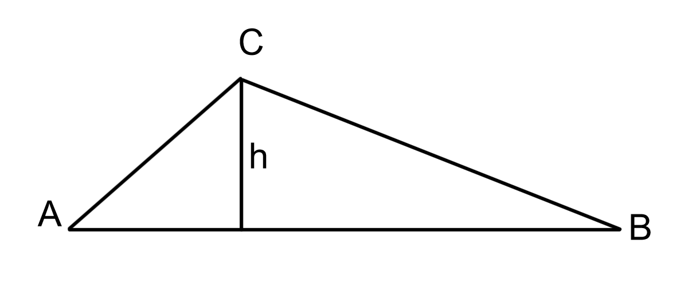
Share: Have groups write their formula on the board.

Summarize: The teacher can rearrange and generalize the Law of Sines from student work.

Day 12

Using the Law of Sines

Objective: Students will solve problems using the law of sines. The problems will be limited to AAS, ASA, and SSA (1 solution cases). Students will explore (potentially) the different cases of SSA and other triangle properties by tying to create their own problem.

Explore: Arrange students into groups of 3-4. Challenge them to use the law of sines to solve the following problems:
- In a triangle A=25, B=110, a=14. Solve the triangle.
- In a triangle A=80, b=10, and a=12. Solve the triangle.
- A telephone pole has tilted 15 degrees towards the rising sun. When the sun is at an angle of elevation of 20 degrees the pole casts a 48ft shadow. How tall was the pole before it tilted?
- A 35ft tall tree is growing on a slope. The slope has an angle of elevation of 10 degrees. When the sun rises to an angle of elevation of 25 degrees the tree’s shadow is directly down the slope. How long is the shadow at this moment?
- Create a triangle with 3 known values that can be solved with the law of sines. Solve your triangle. Then, trade problems with another group and solve their problem. Compare your answers.
Share: Groups construct their solutions on the board.

Summarize: The teacher checks the drawings and work to verify that students have found the correct solutions. The teacher should identify and correct any misunderstandings, notations, expressions, and calculator processes. Pay particular attention to the opportunity for students to find triangles that don’t work or have multiple solutions especially those from SSA.

Assignment: A select number of Law of Sines problems from the course text as appropriate. Be cautious to limit the number of SSA items in the assignment.

Day 13

Jack’s Shack Sandwich Shop

Objective: Students will identify the ambiguous triangle (SSA) and each of its three possible cases with 0, 1, or 2 solutions. They will find all possible solutions for any SSA triangle.

Launch: You have applied for a job at the Jack’s Shack, our new sandwich and coffee shop in the rebuilt media center. To get the job you must show you can prepare the very popular triangle shaped sandwiches. The menu consists of six special sandwiches:
The SSS (Spicy Summer Sausage) | The SSA (Super Sized Antelope)
The AAA (Authentic Angler Anchovy) | The ASA (Abnormally Seasoned Asparagus)
The SAS (Succulent Aromatic Salami | The SAA (Sesame Adobo Avocado)

The chefs decide whether or not you can cut the mustard. Make each sandwich by reading the recipe, constructing the triangles, getting approval, and cutting them out.
Each sandwich must contain all given information. You may decide any length or angle not in the recipe. Name each shape with the recipe and your group name. Be sure names and labels are neat as the chefs must judge many applicants work.

Explore: Students are in groups of 3-4 to make the triangles. Provide them with paper, ruler, compass, protractor and monitor groups to help with constructions.
Recipes: All recipes are based on a triangle ABC. Lengths are in cm and angles are in degrees.
The SSS (Spicy Summer Sausage)  a=15, b=9, c=7 | The SSA (Super-Sized Antelope)  a=13, b=8, A=40
The AAA (Authentic Angler Anchovy)  A=60, B=80, C=40 | The ASA (Abnormally Seasoned Asparagus)  A=60, c=13, B=45
The SAS (Succulent Aromatic Salami)  a=9, B=65, c=11 | The SAA (Sesame Adobo Avocado)  A=40, B=55, a=8

Share: Students move about the room comparing their products. They may share difficulties or persuade each other about their results.

Summarize: Students should find SSA fails to make a triangle. Suggest they try b =10. They should discover 2 triangles exist. Suggest a number larger than 13, they should find 1 triangle.
Outline the different options vs the height of the triangle, find h using sin(A) = h/b. Solve each of the following:
1) A=30, b=10, a=4 2) A=30, b=10, a=5
3) A=30, b=10, a=7 4) A=30, b=10, a=11

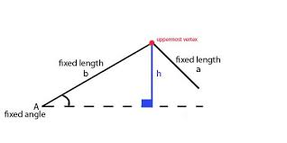
Assign appropriate text problems for practice.

Day 14

Lesson 4: Bearings and Treasure

Objective: Students will construct triangles and represent object’s paths using bearings. They will know bearings are based on the compass with North as 0 degrees and increasing clockwise for 1 revolution.

Launch: Jack Sparrow has hidden a treasure on Isla de Muerta. In order to find the treasure, we must learn how to give and read directions using distances, maps, and compasses. We will divide the class into teams of 3-4 students, each representing a different pirate clan. Each clan is to develop their own method for navigation. The clans must share their systems and determine a single method. Only by working together, will they be able to find the treasure. This activity was found at tes, an educational website, https://www.tes.com/teaching-resource/bearings-pirates-of-the-caribbean-themed-6344815?theme=0 on July 21, 2017.

Explore: Provide groups with rulers, paper directional compasses, and maps of Isla de Muerta. Each clan is to define their own way to navigate. Then, they are to design directions to travel from Lands End to Hangman’s Tree and then to Skull Rock. Note the paper compass will work if cut out and aligned with North on the map.

Share: Each clan is to present their system and how the directions work. After all presentations, groups should discuss which system is best. Then, each clan cast one vote for the system all will use in the future. They may not vote for their own and they should provide reasons for their choice.

Summarize: The teacher should summarize what makes of good navigational system. Present the class with the bearings method if necessary. Provide groups with the treasure directions and challenge them to find the correct location of the treasure.

Explore: Groups are to work together to solve the following problems:
- An airplane flies 100mi from city A to City B at a heading of 040. Then if flies from city B to City C at a heading of 120. Finally, it flies from C back to A at a heading of 230. How far is it from B to C and from C to A?
- Lighthouse A is due North of lighthouse B. Both note the position of a kayak at K. The bearings to K are 110 and 25 from A and B respectively. How far is the kayak from each lighthouse?
Share/Summarize: Groups present their solutions. Teacher monitors for correct drawings, methods, and solutions.

Assignment: Assign problems from class text as appropriate.

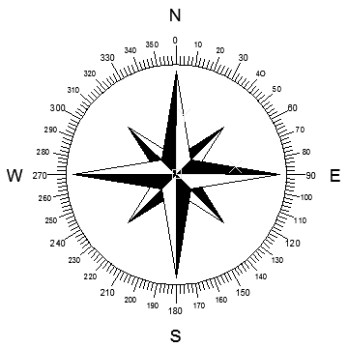

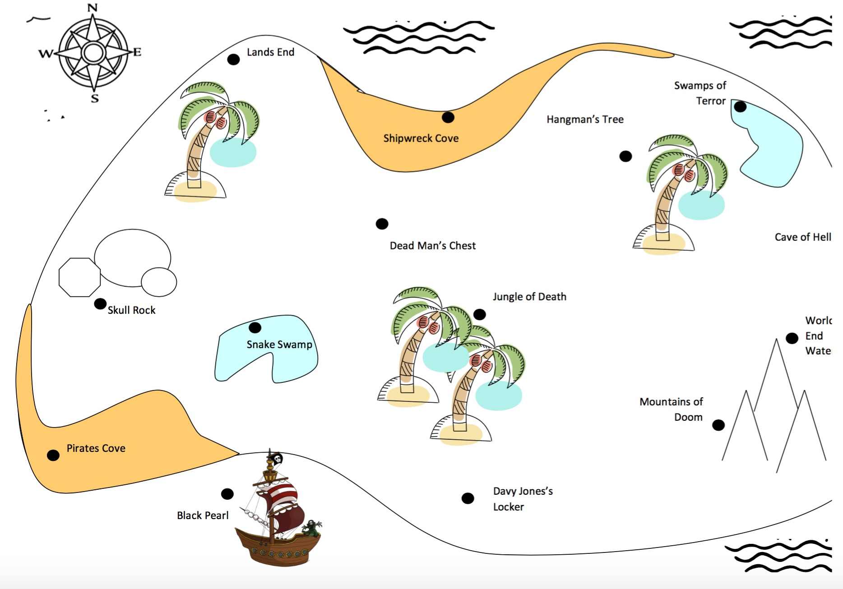

Find Jack Sparrow’s Treasure

Start at Skull Rock

Follow a bearing of 075° for 9.5cm
Take a bearing of 162° for 9.5 cm
Now follow a bearing of 035° for 16cm
Walk 9.5cm on a bearing of 268°
Follow a bearing of 140° for 13.5cm
Next, change your bearing to 305° and follow this for 20cm
Now follow a bearing of 204° for 14cm
Next, take a bearing of 077° for 27.5cm
The next bearing is 262°. You should follow this for 20cm
Now follow a bearing of 190° for 5.5cm
Next, take a bearing of 075° for 19cm
For the next 10cm, follow a bearing of 274°
Now, move on a bearing of 113° for 8.5cm
Take a bearing of 340° for 9.5 cm, here lies your treasure.

Find Jack Sparrow’s Treasure ANSWERS

Start at Skull Rock

Follow a bearing of 075° for 9.5cm – deadman’s chest
Take a bearing of 162° for 9.5 cm – davy jones’ locker
Now follow a bearing of 035° for 16cm – swamps of terror
Walk 9.5cm on a bearing of 268°- shipwreck cove
Follow a bearing of 140° for 13.5cm – mountains of doom
Next, change your bearing to 305° and follow this for 20cm – lands end
Now follow a bearing of 204° for 14cm – pirates cove
Next, take a bearing of 077° for 27.5cm – cave of hell
The next bearing is 262°. You should follow this for 20cm – snake swamp
Now follow a bearing of 190° for 5.5cm – black pearl
Next, take a bearing of 075° for 19cm – world’s end waterfall
For the next 10cm, follow a bearing of 274° - jungle of death
Now, move on a bearing of 113° for 8.5cm – mountains of doom

Take a bearing of 340° for 9.5 cm, here lies your treasure – hangman’s tree.

Day 15

Trig Treasure Hunt! Can you Read the Sines?

Objectives:
- Students will solve oblique triangles using the law of sines given two sides and one angle or two angles and one side.
- Students will solve the ambiguous triangle (SSA) for 0, 1, or 2 solutions. Further, students will be able to solve word problems containing these triangles.
- Students will draw and solve word problems were directions are given in bearings.
Launch: Organize the class into 8 teams. Number the teams from 1-8. Each team is to complete the treasure hunt by following the directions on each problem. The problems are on separate sheets of paper placed about the room. Encourage teams to take pictures of the problems as they proceed and complete the problems in a work area. Each team starts with the same problem whose number matches their team number. Each team is to record and present the orders in which they do all the problems.

Share/Summarize: Allow time to review solutions and problems to clarify students’ understandings and correct any mistakes.

Solution Path: 1-3-8-4-5-2-7-6 or other circuits in the same order.

Post Test: The Trig Treasure Hunt can be used as a post test for formative assessment at this point in the unit. Following this content, it is customary to teach the area formula Area = abSin(C) and the Law of Cosines before moving on to vectors.

Problem 1
Rumor has it there are tunnels underground between the Cloquet school buildings. (Lunch may or may not be carried through these hypothetical tunnels. Imagine you and a friend found 3 such tunnels connecting Washington, CHS Auto shop, and the Middle School Pool. The tunnel from Washington to the Auto shop is 2900ft and lies at a bearing of 10 degrees. The tunnel from Washington to the Middle School Pool has a bearing of 15 degrees. The tunnel from the Auto shop to the Middle School Pool has a bearing of 85 degrees. If you and your friend walk a complete circuit through the tunnels, how far will you have walked?
- 6227ft do problem 3 next
- 8700ft do problem 6 next
- 5725ft do problem 9 next
- None of these, go to problem 2 next

Problem 2
For triangle ABC: A=50, B=60, and a=12. Solve the triangle.
- C=70, a=13.6, b=14.7 do problem 8 next
- C=70, a=14.7, b=13.6 do problem 7 next
- C=70, a=5, b=13 do problem 6 next
- None of these, go to problem 3 next
Problem 3
For triangle ABC: A=105, b=8, and a=14. Solve the triangle.
- B=44, C=31, c=10.8 do problem 2 next
- B=44, C=31, c=7.998 do problem 5 next
- B=31, C=44, c=10.8 do problem 8 next
- None of these, go to problem 4 next
Problem 4
How many solutions are there to triangle ABC if a=10, b=25, and c=40?
- Infinitely many do problem 2 next
- 2 do problem 3 next
- 1 do problem 4 next
- None of these, go to problem 5 next

Problem 5
How many solutions are there to triangle ABC if a=10, b=25, and c=30?
- Infinitely many do problem 1 next
- 2 do problem 7 next
- 1 do problem 2 next
- None of these, go to problem 6 next
Problem 6
How many solutions are there to triangle ABC if A=15, c=19, and a=6?
- Infinitely many do problem 8 next
- 2 do problem 1 next
- 1 do problem 3 next
- None of these, go to problem 7 next

Problem 7
How many solutions are there to triangle ABC if A=15, c=19, and a=4?
- Infinitely many do problem 8 next
- 2 do problem 2 next
- 1 do problem 4 next
- None of these, go to problem 6 next

Problem 8
For triangle ABC: A=35, c=21, and a=17. Solve the triangle.
- B=10, C=135, b=5.1 do problem 5 next
- B=100, C=45, b=29.1 do problem 3 next
- Both of these, go to problem 4 next
- None of these, go to problem 1 next

Geometry Pretest

- For triangle ABC: A=50, B=60, and a=12. Solve the triangle.

- How many solutions are there to triangle ABC if a=10, b=25, and c=30?

- Given the sequence 27, 9, 3, 1…. Find a formula for the nth term.

- Find the area of the figure below:
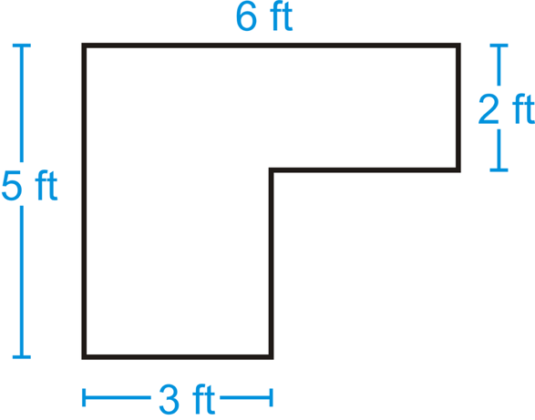

- Describe the transformation that is shown below. Use ΔABC as the pre-image and ΔPQR as the image.
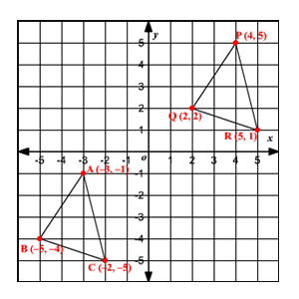

Geometry Post Test

- How many solutions are there to triangle ABC if A=15, c=19, and a=6?

- For triangle ABC: A=105, b=8, and a=14. Solve the triangle.

- Given the sequence 24, 12, 6, 3…. Find a formula for the nth term.

- Find the area of the figure below:
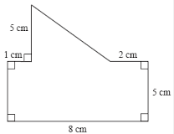

- Describe the dilation that is shown below.
